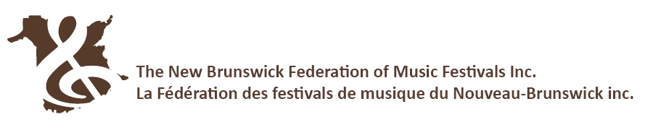

NB PROVINCIAL MUSIC FESTIVAL FINALS
May 29-June 3, 2023
Sackville, NB

POTENTIAL PROVINCIAL FESTIVAL ENTRIES 2023

Name of Local Festival: ___________________________________________________________________

Festival Administrators: Once your festival’s entry deadline has passed, please fill out this sheet and return it to the NBFMF office by email to info@nbfmf.org. The information on this form is necessary for the preliminary scheduling of Provincial Festival Finals Classes. Please indicate which Provincial Festival Finals class[es] for which your festival could potentially have a recommendation. If 2 entries are possible, please check both boxes.

VOCAL □ □ Junior □ □ Intermediate □ □ Advanced
PIANO □ □ Junior □ □ Intermediate □ □ Advanced
STRINGS □ □ Junior □ □ Intermediate □ □ Advanced
CLASSICAL GUITAR □ □ Junior □ □ Intermediate □ □ Advanced
WOODWINDS □ □ Junior □ □ Intermediate □ □ Advanced
BRASS □ □ Junior □ □ Intermediate □ □ Advanced
PERCUSSION □ □ Junior □ □ Intermediate □ □ Advanced
MUSICAL THEATRE □ □ Junior □ □ Intermediate □ □ Advanced
CHAMBER ENSEMBLE □ □ Junior □ □ Intermediate □ □ Advanced
COMPOSITION - SOLO/DUO □ □ Junior □ □ Intermediate □ □ Advanced
COMPOSITION - ENSEMBLE □ □ Junior □ □ Intermediate □ □ Advanced
CANADIAN COMPOSER □ □ Junior □ □ Intermediate □ □ Advanced

CHORAL CLASSES
□ □ Class 9101 School or Community Glee/Show/Musical Theatre Group
- □ Class 9102 School Grades 12 & under
- □ Class 9103 School Grades 9 & under
- □ Class 9104 School Grades 6 & under

- □ Class 9110 Community 19 & over
- □ Class 9111 Community 19 & under
- □ Class 9112 Community 16 & under
- □ Class 9113 Community 12 & under

- □ Class 2305 Canadian Composer – Elementary School Choir
- □ Class 2306 Canadian Composer – Middle / High School Choir
- □ Class 2307 Canadian Composer – Youth Community Choir
- □ Class 2308 Canadian Composer – Adult Community Choir

BAND CLASSES
- □ Class 9301 School Concert Band
- □ Class 9302 School Jazz Band
- □ Class 9303 Community Concert Band
- □ Class 9304 Community Jazz Band

ORCHESTRA CLASSES
- □ Class 9401 School Full Orchestra [including strings, winds, and percussion]
- □ Class 9402 School String Orchestra
- □ Class 9403 Community Full Orchestra [including strings, winds, and percussion]
- □ Class 9404 Community String Orchestra

