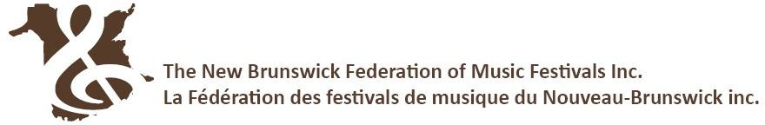
ADJUDICATOR Recommendations to the NB PROVINCIAL MUSIC FESTIVAL FINALS - ENSEMBLE STREAM
Festival Administrators: This is a preliminary list of entries recommended to the NB Provincial Music Festival Finals.
This form does not constitute an entry.
Each recommended group must register at https://www.nbfmf.org/registration-inscription/ by May 5.

Immediately following the conclusion of your festival, please email these recommendations to the NBFMF office info@nbfmf.org

FESTIVAL: _________________________________________________________________________________________
DISCIPLINE: Please indicate discipline and use a separate form for each discipline and adjudicator. Use multiple pages as needed.
_____ CHOIR _____ BAND _____ ORCHESTRA
CLASS # | RECOMMENDED GROUP | ALTERNATE RECOMMENDATION, if applicable
 | Selections:  1.  2. | Selections:  1.  2.

CLASS # | RECOMMENDED GROUP | ALTERNATE RECOMMENDATION, if applicable
 | Selections:  1.  2. | Selections:  1.  2.

CLASS # | RECOMMENDED GROUP | ALTERNATE RECOMMENDATION, if applicable
 | Selections:  1.  2. | Selections:  1.  2.

Adjudicator’s Signature ____________________________________________________ Date __________________________
On behalf of this local festival, I submit the above entries as our officially recommended representatives to the 2024 New Brunswick Provincial Music Festival Finals.

Signature of Festival Representative ___________________________________________ Date ______________________________
New Brunswick Federation of Music Festivals | 11119 Route 130, Somerville, NB E7P 2S4
www.nbfmf.org (506) 245-1689 info@nbfmf.org

