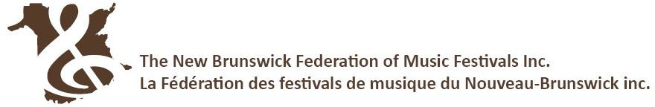
ADJUDICATOR RECOMMENDATIONS TO THE PROVINCIAL MUSIC FESTIVAL FINALS – SOLO AND CHAMBER CLASSES
Festival Administrators: This is a preliminary list of individuals recommended to the Provincial Festival.
This form does not constitute entry to the Provincial Festival.
Immediately following the conclusion of your festival, email these recommendations to the NBFMF office.
Each recommended individual must register on-line at https://www.nbfmf.org/registration-inscription/ and submit entry fee by May 5 in order to fulfill entry requirements.

FESTIVAL:

DISCIPLINE: [only one discipline and adjudicator per sheet] _

Junior | Recommended: | Selections:  1.  2.
 | Recommended: | Selections:  1.  2.
 | Alternate: | Selections:  1.  2.
 | Alternate: | Selections:  1.  2.
Intermediate | Recommended: | Selections:  1.  2.
 | Recommended: | Selections:  1.  2.
 | Alternate: | Selections:  1.  2.
 | Alternate: | Selections:  1.  2.
Advanced | Recommended: | Selections:  1.  2.
 | Recommended: | Selections:  1.  2.
 | Alternate: | Selections:  1.  2.
 | Alternate: | Selections:  1.  2.

Adjudicator’s Signature
_ _ _ Date

On behalf of this local festival, I submit the above individuals as our officially recommended representatives to the 2024 NB Provincial Music Festival Finals.

Signature of Festival Contact or Representative |  | Date

New Brunswick Federation of Music Festivals 11119 Route 130, Somerville, NB E7P 2S4 (506) 245-1689 Email: info@nbfmf.org

